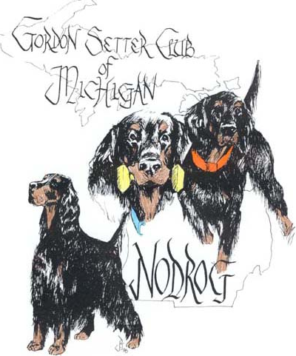
NODROG
GORDON SETTER CLUB OF MICHIGAN
2025 – 2026
AWARDS

Club Member: ______________________________________________________________

Reg. Name Dog: ____________________________________________________________

Dog’s Call Name____________________________________________________________

You have the option to receive a Plaque, Title Bar or
Certificate of Achievement.
If you don’t specify, you will receive a Certificate of Achievement.
(Plaque/Bar)
(Bar)
(Certificate)

Award: __________________________________ Date: _____________ __________

Award: __________________________________ Date: _____________ __________

Award: __________________________________ Date: _____________ __________

Events Worked At:

______________________________________________________ Date: ________________

______________________________________________________ Date: ________________

______________________________________________________ Date: ________________

Per Dog - Club member MUST work a minimum of THREE club events to be eligible for a
Free plaque and 1st initial bar
Additional Plaques and/or Additional Title Bars are at club members expense (please ask for price) Credit Card Option Available
Club member MUST work ONE club event to be eligible for a Certificate of Achievement
Awards will be awarded at the Annual Picnic – July 18, 2026
Awards may be mailed at owner’s expense
Deadline for submission - - - June 30, 2026
Mary Grill – 625 N. Force Rd. – Attica, MI 48412
Krystaless@hotmail.com

